Your first Angular Project
- Start a new command window with admin right
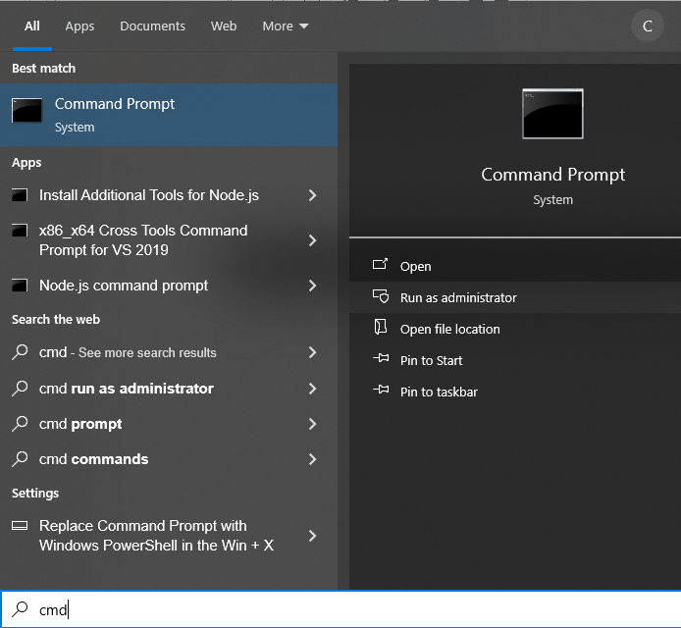
- In the command window, run each of the following command
  - cd\
  - md Day2
  - cd Day2
  - ng new MyFirstProj (Answer all questions with default settings and wait)
  - cd MyFirstProj
  - code . (There is a space in between code and dot)
Now you should open the Visual Studio Code for your new project folder.
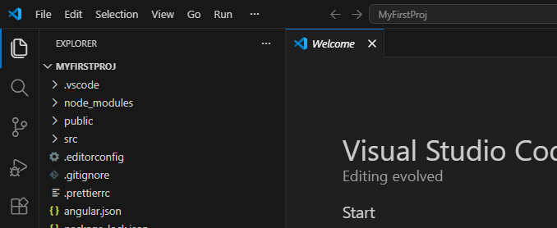
- In VS Code, open a new Terminal Window.
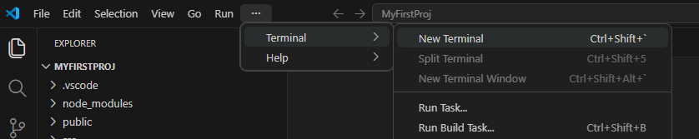
You should get the window at the bottom of VS Code
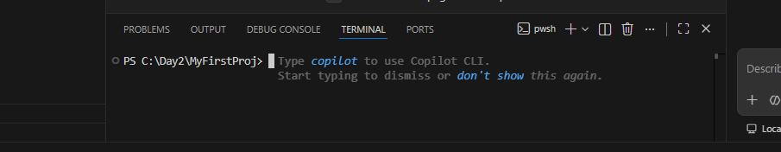
- In the terminal window, ng serve --open
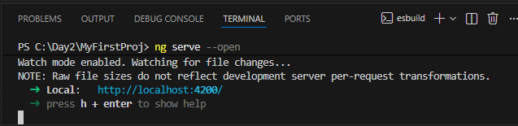
This will start the default web browser for the website
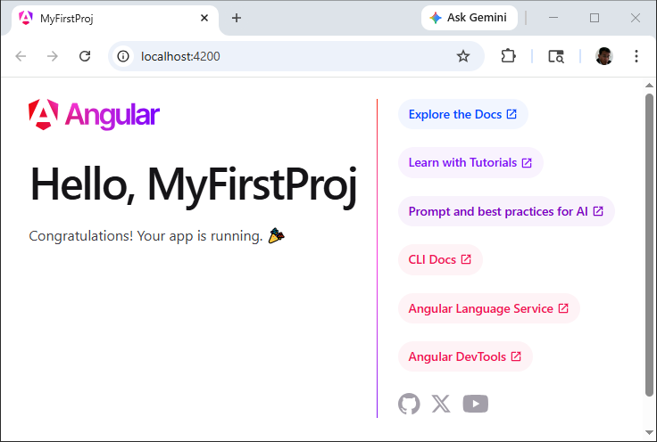
Your website now is up and running.
- Close the web browser.
- Back to VS Code. In the terminal window, press <Ctrl>+C. This will stop the web server
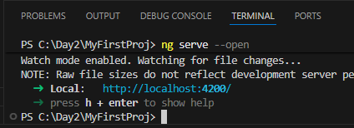
- In the Project Explorer Windows, open MYFIRSTPROJ/src/app/app.html
- Clear everything in the app.html except the last statement
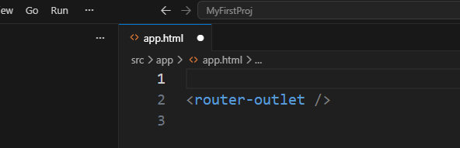
- Add some new html content, and save the file
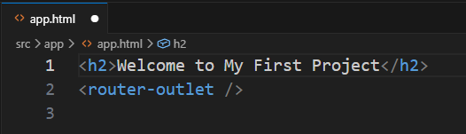
- Back to Terminal Windows, run ng serve –-open –-port 8888
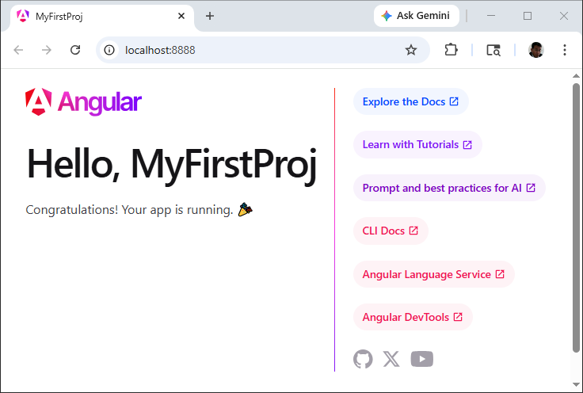
You are running your website again. Pay attention to the port number and the new content.
- Close the browser and stop the webserver.

